Batch: A-2 Roll No.: 16010122034

Experiment / assignment / tutorial No. 2 Grade: AA / AB / BB / BC / CC / CD /DD

Signature of the Staff In-charge with date
TITLE: To study and implement Booth’s Multiplication Algorithm.

AIM: Booth’s Algorithm for Multiplication

Expected OUTCOME of Experiment: (Mention CO/CO’s attained here)

Books/ Journals/ Websites referred:
- Carl Hamacher, Zvonko Vranesic and Safwat Zaky, “Computer Organization”, Fifth Edition, TataMcGraw-Hill.
- William Stallings, “Computer Organization and Architecture: Designing for Performance”, Eighth Edition, Pearson.
- Dr. M. Usha, T. S. Srikanth, “Computer System Architecture and Organization”, First Edition, Wiley-India.

Pre Lab/ Prior Concepts:
It is a powerful algorithm for signed number multiplication which generates a 2n bit product and treats both positive and negative numbers uniformly. Also the efficiency of the algorithm is good due to the fact that, block of 1’s and 0’s are skipped over and subtraction/addition is only done if pair contains 10 or 01

Flowchart:

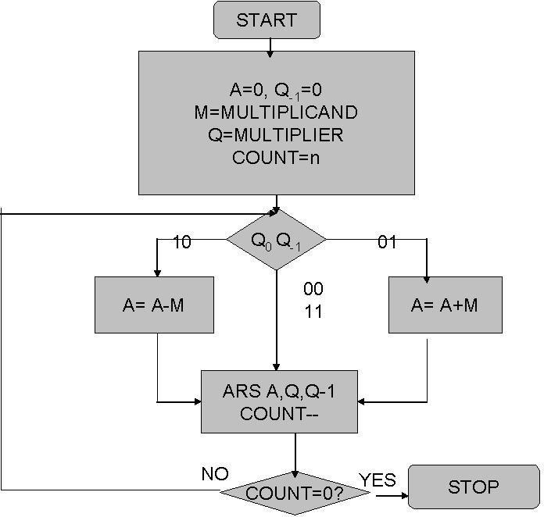

Design Steps:

- Start
- Get the multiplicand (M) and Multiplier (Q) from the user
- Initialize A= Q-1 =0
- Convert M and Q into binary
- Compare Q0 and Q-1 and perform the respective operation.

Q0 Q-1 | Operation
00/11 | Arithmetic right shift
01 | A+M and Arithmetic right shift
10 | A-M and Arithmetic right shift

- Repeat steps 5 till all bits are compared

- Convert the result to decimal form and display
- End

Code:

#include <stdio.h>
#include <stdlib.h>

int input_number();
int binary_to_decimal(int bin);
int * decimal_to_binary(int deci);
int compute_length(int num);
void booth_algo(int * m, int * q, int size);

int main(){

int mDeci;
printf("Enter Multiplicand: ");
scanf("%d", &mDeci);
int *pm = decimal_to_binary(mDeci);

int deci_q = 0;
printf("Enter Multiplier: ");
scanf("%d", &deci_q);
int *pq = decimal_to_binary(deci_q);

booth_algo(pm, pq, 5);

return 0;
}

int * decimal_to_binary(int deci){
int *bin = (int*)calloc(4, sizeof(int));

if(deci < 0){
bin[0] = 1;
deci = abs(deci);
}
else
bin[0] = 0;
for(int i = 0; i < 4 ; i++){
int digit = deci % 2;
deci /= 2;
bin[4 - i] = digit;
}
if (bin[0] == 1){
for (int i=1; i < 4; i++){
if (bin[i] == 1)
bin[i] = 0;
else
bin[i] = 1;
}
}

return bin;
}

int input_number(){
int num = 0;
printf("Input a number: ");
scanf("%d", &num);
return num;
}

void booth_algo(int * m, int * q, int size){

int q0 = 0;
int * a = (int *)calloc(size, sizeof(int));

printf("m: ");
for (int i = 0; i < size; i++)
printf("%d", m[i]);
printf("\ta: ");
for (int i = 0; i < size; i++)
printf("%d", a[i]);
printf("\tq: ");
for (int i = 0; i < size; i++)
printf("%d", q[i]);
printf("\tq (-1): %d\n", q0);

// TWOS COMP
int * mcomp = (int *)calloc(size, sizeof(int));
int found_one = 0;
for(int j = 1; j <= size; j++) {
int place = size - j;
int digit = m[place];
if (found_one == 1) {
if(digit == 1)
mcomp[place] = 0;
else
mcomp[place] = 1;
continue;
}
mcomp[place] = m[place];
if (m[place] == 1)
found_one = 1;
}

printf("\nM 2's COMP:\t");
for (int i = 0; i < size; i++)
printf("%d", mcomp[i]);
printf("\n");

for (int i = 0; i < size; i++){
printf("\n------------- CYCLE %d -----------\n", i + 1);

for (int i = 0; i < size; i++)
printf("%d", a[i]);
printf("\t");
for (int i = 0; i < size; i++)
printf("%d", q[i]);
printf("\t%d", q0);
printf("\n");

if (q[size - 1] == 0 && q0 == 1){

// ADD a and m
int c = 0;
for (int j = 1; j <= size; j++){
int p = size - j;
int sum = m[size - j] + a[size - j] + c;
if(sum == 3){
a[size - j] = 1;
c = 1;
}
else if (sum == 2){
a[size - j] = 0;
c = 1;
}
else if (sum == 1){
a[size - j] = 1;
c = 0;
}
else {
a[size - j] = 0;
c = 0;
}
}
printf("After A -> A + M: ");
for (int i = 0; i < size; i++)
printf("%d", a[i]);
printf("\t");
for (int i = 0; i < size; i++)
printf("%d", q[i]);
printf("\n");

}
else if (q[size - 1] == 1 && q0 == 0){

// ADD a and mcomp
int c = 0;
for (int j = 1; j <= size; j++){
int p = size - j;
int sum = mcomp[size - j] + a[size - j] + c;
if(sum == 3){
a[size - j] = 1;
c = 1;
}
else if (sum == 2){
a[size - j] = 0;
c = 1;
}
else if (sum == 1){
a[size - j] = 1;
c = 0;
}
else {
a[size - j] = 0;
c = 0;
}
}
printf("After A -> A + (-M): ");
for (int i = 0; i < size; i++)
printf("%d", a[i]);
printf("\t");
for (int i = 0; i < size; i++)
printf("%d", q[i]);
printf("\n");
}

// RIGHT SHIFT
q0 = q[size - 1];
for (int j = size - 1; j > 0 ; j--){
q[j] = q[j - 1];
}
q[0] = a[size - 1];
for (int j = size - 1; j > 0; j--){
a[j] = a[j - 1];
}
a[0] = a[1];

// PRINTING CYCLE
for (int i = 0; i < size; i++)
printf("%d", a[i]);
printf("\t");
for (int i = 0; i < size; i++)
printf("%d", q[i]);
printf("\t%d\n", q0);
}
}

Output:

Enter Multiplicand: 7
Enter Multiplier: 3
m: 00111 a: 00000 q: 00011 q (-1): 0

M 2's COMP: 11001

------------- CYCLE 1 -----------
00000 00011 0
After A -> A + (-M): 11001 00011
11100 10001 1

------------- CYCLE 2 -----------
11100 10001 1
11110 01000 1

------------- CYCLE 3 -----------
11110 01000 1
After A -> A + M: 00101 01000
00010 10100 0

------------- CYCLE 4 -----------
00010 10100 0
00001 01010 0

------------- CYCLE 5 -----------
00001 01010 0
00000 10101 0

Example: (Handwritten solved problem needs to be uploaded)
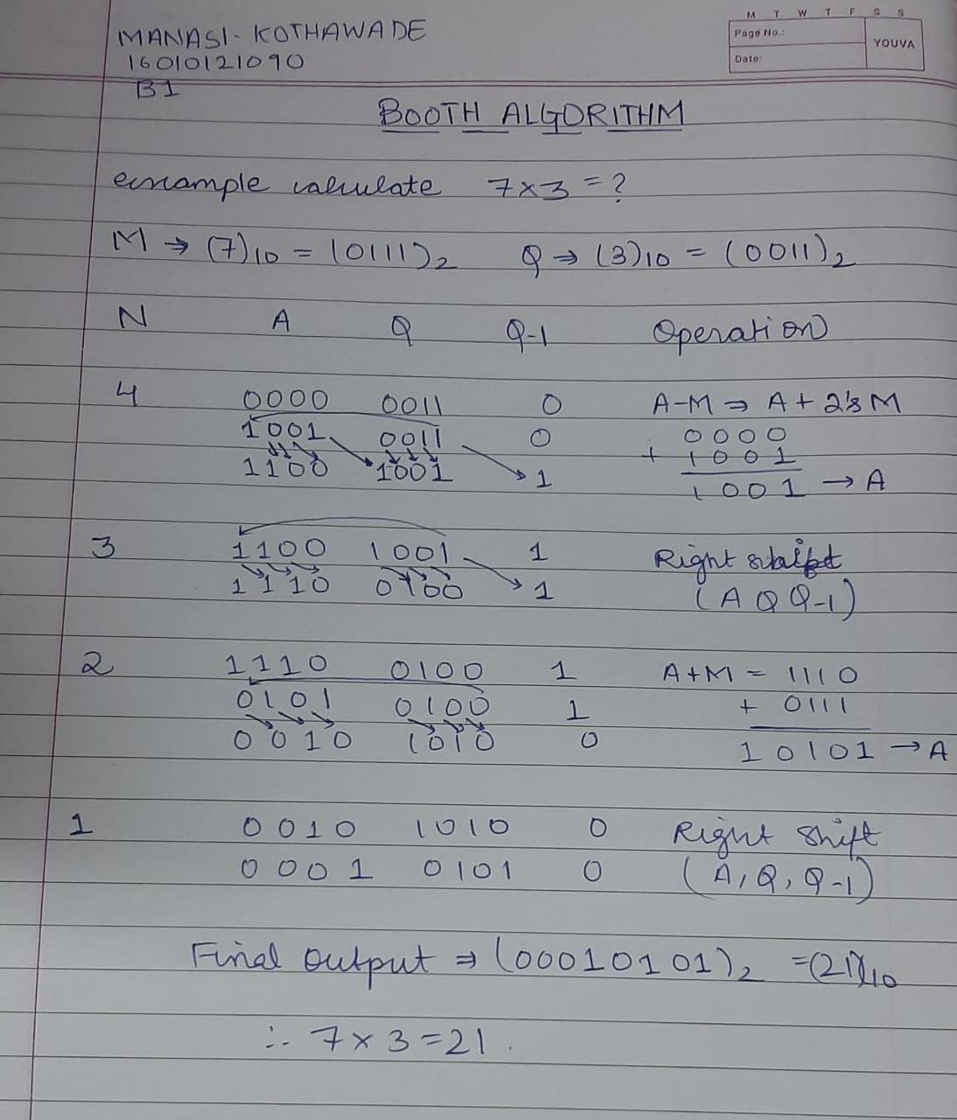

Conclusion: Through this experiment, the method to multiply two binary numbers was learnt. New operations like right shift were also acquired. In the research for the Post Lab Question I understood Booth’s Recoding Method and its advantages.
Post Lab Descriptive Questions

Question: Explain advantages and disadvantages of Booth’s algorithm.
Answer:
Advantages of booth's multiplication:

Easy calculation of multiplication problem.
Consecutive additions will be replaced.
Less complex and ease scaling.

Disadvantages of booth's multiplication:

This algorithm will not work for isolated 1's.
It is time consuming.
If digital gates are more, chip area would be large.

Question: Is Booth’s recording better than Booth’s algorithm? Justify Answer:
Advantage of Booth’s recoding is that it reduces the number of 1’s and increases the number of 0’s in a binary number. Having more number of 0’s is advantageous for easier calculation.
For Example: 01111 is equivalent to (+1 0 0 0 -1) in Booth Recoding.

Date: 12/08/2023 Signature of faculty in-charge

